PROGRAMME: BSSE/BSCS/BIT
YEAR/SEM: YEAR 2 SEM 1
COURSE CODE: BIT2115
PROBLEM NAME: JAVA ACCESS MODIFIERS

STUDENT DETAILS:
NAME OF STUDENT | Ngemani Charles
REG NUMBER | 25/U/167/BIT-S
GITHUB LINK

Table of Contents
Contents Pages
Section 1 2
Logic Building & Programming 2
1.1. Lines of code & explanations 2
1.2. Understanding the system requirement 3
1.2.1. Patient Information Package – Patient Details Class 3
1.2.2. Doctor Information Package – Doctor Details Class 3
1.2.3. Reception Information Package – Reception Details Class 3
1.2.4. Finance Information Package – Financial Details Class 3
1.2.5. Hospital Management App 4
1.3. Console Input and Output 8
Section 2 10
What Have You Learned From The Task? 10

List of Figures

Figure 1: Code structure – patient details 4
Figure 2: Code structure - doctor details 5
Figure 3: Code structure - reception section 6
Figure 4: Code structure - finance section 7
Figure 5: Code structure - Hospital management App - main method. 8
Figure 6: Console Scanner Input - user input 9
Figure 7: Final output 10

Section 1

Logic Building & Programming

Lines of code & explanations
Line Number | Explanation
PatientDetails
1 | Information about the package
2 | This is a publicly accessible class that defines the structure and behaviour of patient records, allowing other parts of the hospital management system to create and use patient objects.
18 | Read the value
19 | Write or update the value
DoctorDetails
2 | It gives access to the patient record structure created in another package.
3 | It enables the program to read user input typed in the console.
5 | Defines a public method that allows the doctor to update a patient’s medical information. It receives a PatientDetails object, meaning all updates made inside this method will be stored directly in that patient’s record.
6 | Creates a Scanner object that captures input typed from the keyboard. This allows the doctor to enter details such as age, sex, diagnosis, treatment, and appointment date during runtime.
7 | Prints a formatted heading on the console to show that the doctor’s section of the program has started. The colour codes (\u001B[34m) simply make the text appear in blue for better visibility.
HospitalManagementApp
1 – 4 | Allow the main class to use other classes from different packages.
6 | The entry point of the program.
7 | Creates an empty patient record that will be filled with data.
13 – 15 | All three lines update, one patient object from three different departments.

Understanding the system requirement
To design a Java program suitable for a private hospital, my first step was to identify the core functional areas of the hospital and organize them into appropriate packages. This ensures that related classes are grouped together, improves maintainability, and supports controlled access to sensitive information. The system is structured into four main packages, each serving a distinct operational role:

Patient Information Package – Patient Details Class
This package contains the class responsible for storing all patient‑related data. Because patient records include sensitive medical and personal information, the variables in this class require strict access control. Using private access for these fields ensures that only authorized classes can modify or retrieve this information through controlled methods. This package forms the foundation of the entire system.

Doctor Information Package – Doctor Details Class
The doctor’s role involves updating medical information such as diagnosis, treatment, and other clinical details. This class interacts with the patient data but should only access the fields relevant to medical updates. By using appropriate access modifiers, the system ensures that doctors can modify medical records while preventing unauthorized departments from altering clinical information. This demonstrates how access levels enforce professional boundaries within the application.

Reception Information Package – Reception Details Class
Receptionists handle basic patient details such as patient ID, and name. These are non‑sensitive fields, so the class is designed to allow limited interaction with patient data. Public access modifiers ensure that receptionists can view or update only the basic information required for front‑desk operations, while preventing them from accessing confidential medical or financial records. This separation protects patient privacy and aligns with real‑world hospital workflows.

Finance Information Package – Financial Details Class
Financial records, including payment methods and amounts, are highly sensitive and is restricted to the hospital’s administration department. This class is designed so that only authorized financial personnel can update or view payment information. Access modifiers play a crucial role here by preventing other departments—such as reception or medical staff—from accessing financial data. This reinforces data security and departmental responsibility.

Hospital Management App
The Hospital Management App class serves as the central controller of the entire hospital system. Its main method acts as the starting point of the program, bringing together all the packages and classes that handle patient, doctor, reception, and finance operations. In this method, the system first creates a patient record and then allows each department to interact with it in a structured workflow. Reception updates basic patient details, doctors add medical information, and the finance department records payment data. Throughout these interactions, the main method ensures that each department only accesses the information permitted by its access level, demonstrating how Java’s access modifiers enforce confidentiality and departmental boundaries. By coordinating object creation, method execution, and final output display, the main class shows how a well‑organized Java application can manage hospital operations securely and efficiently.
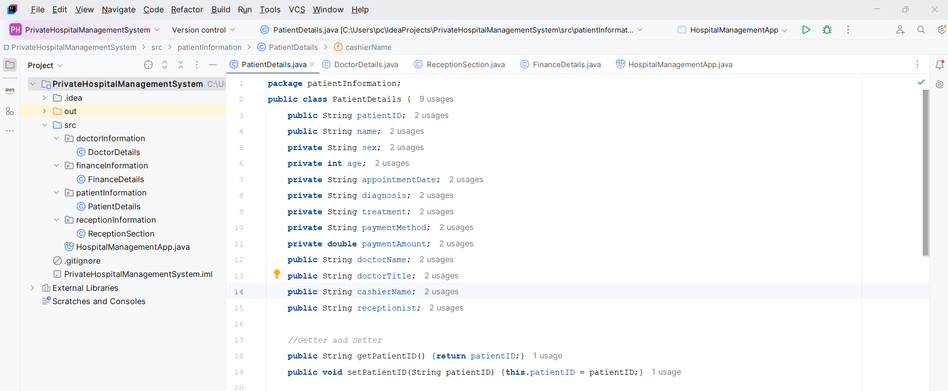
Figure 1: Code structure – patient details
Figure 1 illustrates the overall structure of the hospital management program. The left panel displays the hierarchy of the project, showing how the system is organized into different packages such as patientInformation, doctorInformation, receptionInformation, and financeInformation, each containing its respective class.
At the top of the window, the various classes created for the system are visible, reflecting the modular design of the application. The main code window shows the PatientDetails class, where variables are declared and the initialization of patient attributes begins. It also demonstrates the use of Getter and Setter methods, which provide controlled access to private fields and ensure that sensitive patient information is securely managed according to the principles of encapsulation.
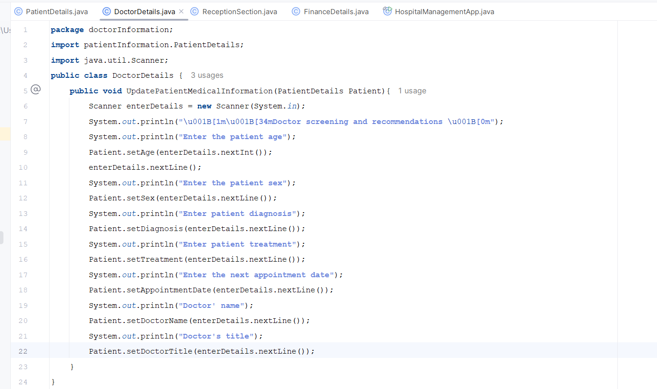
Figure 2: Code structure - doctor details
The Figure 2 is the DoctorDetails class which represents the doctor’s role in the hospital management system. Its main responsibility is to update a patient’s medical information. Inside this class, the method UpdatePatientMedicalInformation() receives a PatientDetails object and uses a Scanner to capture input from the keyboard. The method guides the doctor through entering clinical details such as the patient’s age, sex, diagnosis, treatment, and next appointment date. It also records the doctor’s name and professional title. Each piece of information entered is stored in the patient record through Setter methods, which ensures that only authorized medical personnel can modify sensitive medical fields. This design demonstrates encapsulation and controlled access, allowing doctors to update medical data while keeping the patient’s information secure and well‑structured within the system.
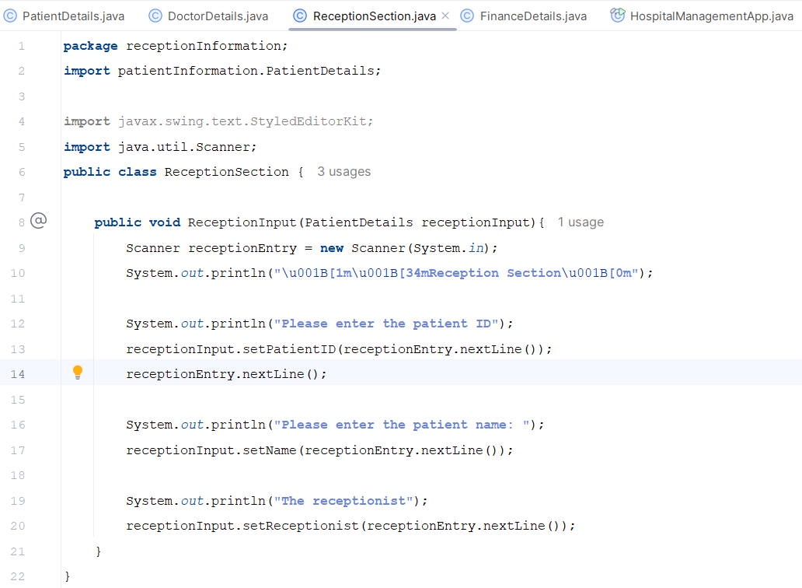
Figure 3: Code structure - reception section
The ReceptionSection class represents the reception department’s role in the hospital management system. Its main method, ReceptionInput, receives a PatientDetails object and uses a Scanner to collect basic patient information from the user. The method prompts the receptionist to enter the patient ID, patient name, and the receptionist’s own name. Each value entered is then stored in the patient record through Setter methods such as setPatientID, setName, and setReceptionist. This design ensures that reception staff can only update non‑sensitive fields, reflect their real‑world responsibility of handling basic registration details while maintain proper access control within the system.

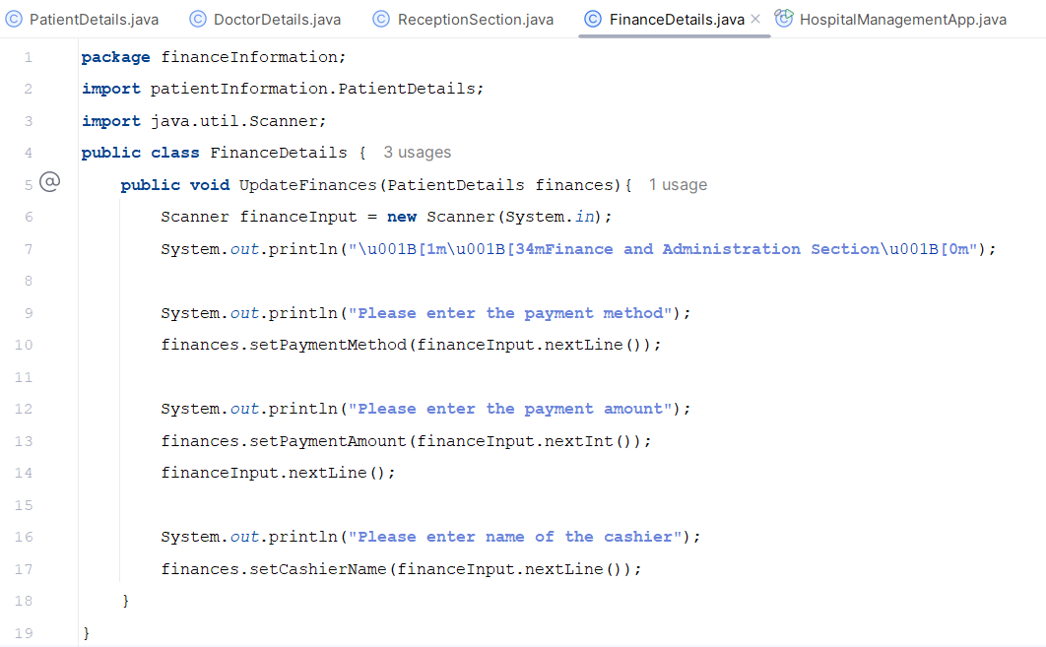
Figure 4: Code structure - finance section
The FinanceDetails class represents the finance and administration department within the hospital management system. Its main method, UpdateFinances, receives a PatientDetails object and uses a Scanner to collect financial information from the user. The method prompts the cashier to enter the payment method, the amount paid, and the cashier’s name. These values are then stored in the patient record using Setter methods such as setPaymentMethod, setPaymentAmount, and setCashierName. This design ensures that only authorized financial staff can update payment‑related fields, reflecting real hospital procedures where financial records are handled separately from medical and reception data. The method demonstrates how encapsulation and access control help protect sensitive financial information while maintaining a structured workflow across different departments.
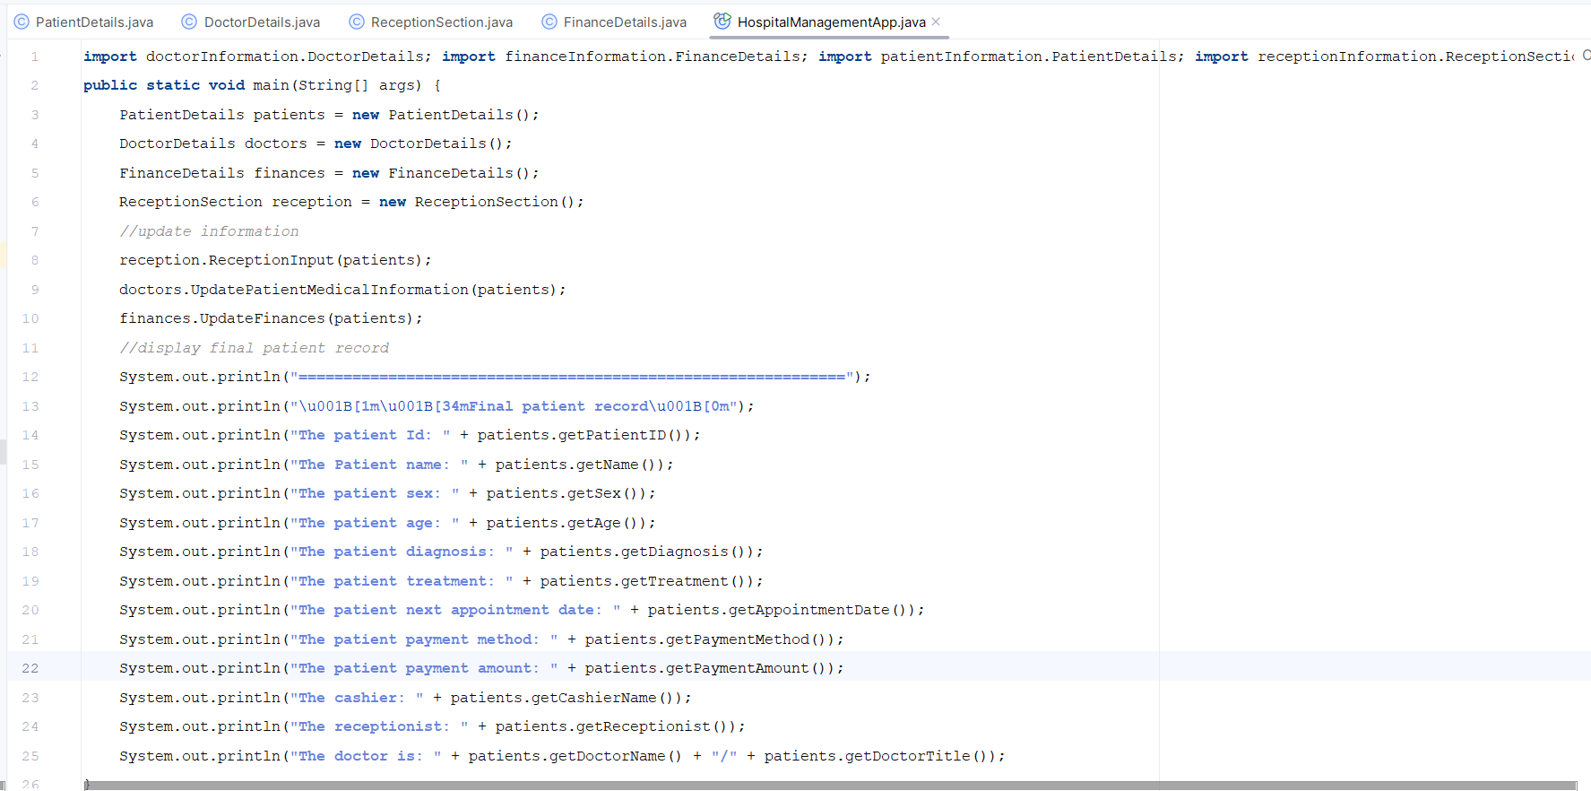
Figure 5: Code structure - Hospital management App - main method.
The HospitalManagementApp class acts as the central controller of the entire hospital management system. Inside this class, the main method coordinates how different departments—reception, doctor, and finance—interact with a single patient record. The method begins by creating objects for PatientDetails, ReceptionSection, DoctorDetails, and FinanceDetails. It then follows a logical workflow like real hospital operations: the reception section collects basic patient details, the doctor updates medical information, and the finance department records payment details. Each department updates only the fields it is authorized to access, demonstrating how encapsulation and access modifiers protect sensitive data. After all updates are completed, the main method prints a consolidated final patient record, showing how information from different packages is integrated into one complete output. This structure highlights the role of the main class as the coordinating point that links all packages and ensures secure, orderly data flow across the system.

Console Input and Output
In the console, two main functions were carried out. The first function involved capturing user input from the keyboard using the Scanner class, allowing the receptionist, doctor, and finance officer to enter patient details directly into the system. The second function involved displaying the final output, which presents a complete summary of the private hospital consultation based on all the information entered by the different departments.
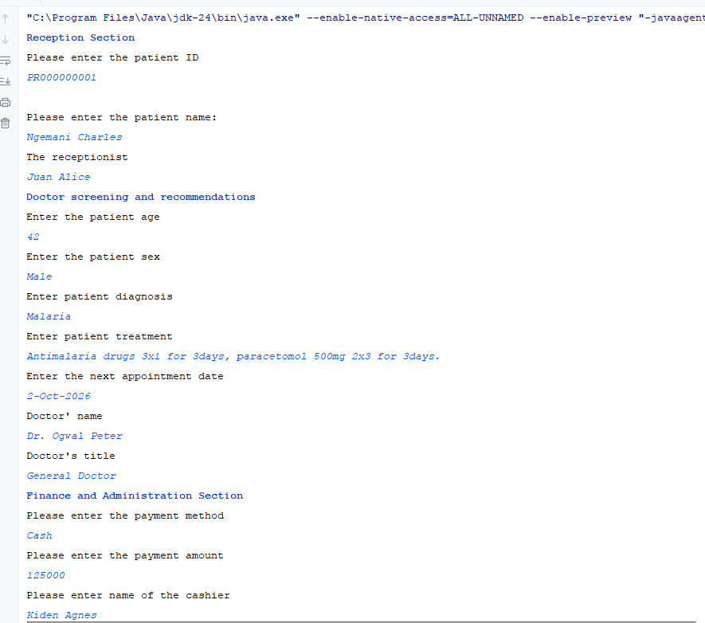
Figure 6: Console Scanner Input - user input
The program uses a Scanner object to capture input directly from the keyboard. This means that before any patient information is displayed or stored, the system first waits for the user—whether a receptionist, doctor, or cashier—to type the required details. The Scanner reads whatever the user enters and passes it into the appropriate Setter methods of the PatientDetails class. This ensures that all information printed in the final patient record is exactly what was typed during the interaction. In simple terms, the Scanner acts as the bridge between the user and the program, collecting typed data and making it available for processing and display.
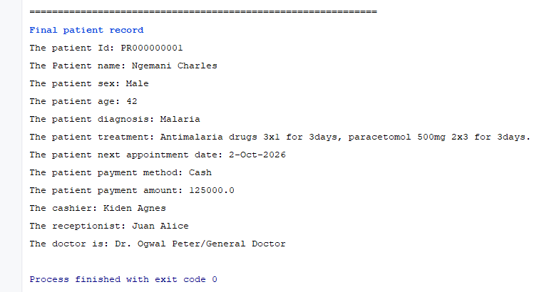
Figure 7: Final output
The final output presents a complete summary of the patient’s consultation at the private hospital. It combines information entered by all departments—reception, doctor, and finance—into one structured record. The output displays the patient’s identification details, medical assessment (including diagnosis, treatment, and next appointment date), and financial information such as payment method and amount. It also lists the staff involved in the process, including the receptionist, cashier, and attending doctor. This final record demonstrates how the system successfully collects, processes, and displays patient data from different sections of the hospital in a single consolidated report.

Section 2

What Have You Learned From The Task?
Skill Set | Description
Identify packages and class | I successfully analyzed the problem statement and was able to identify and construct all the required packages and classes for the system.
Identify attributes for each class | I correctly determined all the essential attributes needed for each class based on the system requirements.
Identify access modifiers for each class | I applied proper access modifiers specifically private and public to ensure correct encapsulation and controlled access to class data.
Learned how to use Scanner class | I learned how to implement the Scanner class to capture user input directly from the keyboard during program execution.
User Getter and Setter method | I effectively used Getter and Setter methods to retrieve and update the respective attributes of each class while maintaining data protection.

Theory Questions (To be submitted in your new books)
- What are access modifiers in Java?
Access modifiers are keywords in Java that control the visibility and accessibility of classes, methods, and variables. They determine which parts of a program can use or modify a particular member.
- Explain the purpose of access modifiers in object-oriented programming.
Their main purpose is to enforce encapsulation—protecting data from unintended access or modification. Access modifiers help organize code securely by restricting or allowing access to class members based on design needs.
- List the four main access modifiers available in Java.
Java provides four access levels:
- public
- private
- protected
- default (package‑private) — applied when no modifier is specified
- Differentiate between public and private access modifiers.
public: Accessible from anywhere in the program, across all packages.
private: Accessible only within the same class; not visible to other classes or subclasses.
- What is the role of the protected access modifier in Java?
The protected modifier allows access within the same package and also by subclasses even if they are in different packages. It is useful for inheritance‑based designs.

